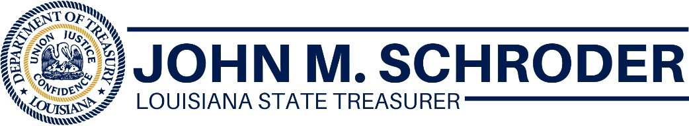
FOR IMMEDIATE RELEASE
Aug. 18, 2020
Treasurer Schroder: Main Street Grants Now Can Be Paid To Additional Small Businesses
BATON ROUGE, LA – State Treasurer John M. Schroder announced today all qualifying small businesses now can receive a grant from the Main Street Recovery Program, even if they got prior federal assistance such as a Paycheck Protection Program loan.
Act 311 of the Louisiana 2020 Regular Session set aside $275 million from the CARES Act for the Louisiana Main Street Recovery Program but prioritized businesses who didn’t receive prior funding for the first 21 days. The restriction ended today.
“The end of the restriction opens up Main Street to thousands of additional small businesses across Louisiana,” said Treasurer Schroder. “Many of them have already applied. We just couldn’t initiate a review of them for the first 21 days of the program. Those who haven’t applied should do so immediately.”
Main Street is designed to reimburse small businesses for pandemic-related expenses through grants. Applications can be completed online at www.louisianamainstreet.com
Main Street offers two grant options:
- Quick Relief will give grants of up to $5,000 to qualifying businesses who received $1,000 or less in federal funding or other assistance.
- Itemized Cost Reimbursement will give grants of up to $15,000 to qualifying businesses who can show eligible normal operating expenses related to the pandemic. Businesses who have received federal assistance will need to show expenses greater than those amounts received to obtain Main Street Recovery funds.
Business owners can use a CPA or other financial professional to help them with the paperwork. Under the program, the professional services cost for assisting a business with this grant application is also a reimbursable expense up to $500.
More than 16,000 applications have been received in the first 21 days of the program. Another 20,000 are needed to complete the program.

###

