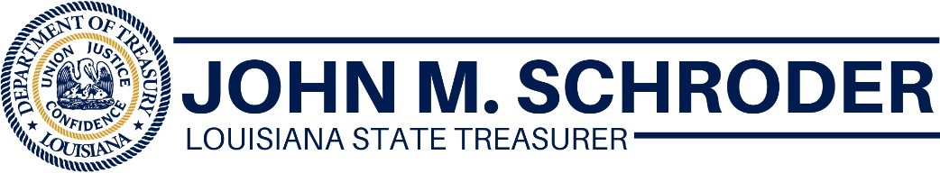
FOR IMMEDIATE RELEASE
September 21, 2020
Main Street Recovery Program Obligates $170 Million To Help Louisiana’s Small Businesses
BATON ROUGE, LA – State Treasurer John M. Schroder today announced the Main Street Recovery Program has obligated $170 million in grants to small businesses with a week remaining before the program reaches the halfway mark.
The number of applications submitted daily increased after changes were made to the Quick Relief option. Applicants now can receive up to $15,000 through the abbreviated application process. In most cases, all they need is a driver’s license and tax returns in order to apply.
“Main Street is working to quickly get money into the hands of small business owners. We want them to keep their business and their workforce intact,” said Treasurer Schroder. “We’re not even at the midway point, and more than half the money is obligated. This program is the support small businesses need during the pandemic.”
The Legislature set aside $275 million for the Main Street Recovery Program. More than 30,000 applications have been submitted since the program began on July 28.
Milestones include:
- Awarding $40 million to businesses owned by minorities, women or veterans.
- A current average award of more than $10,000 per business.
Small businesses can visit www.louisianamainstreet.com to apply for a grant.

###

